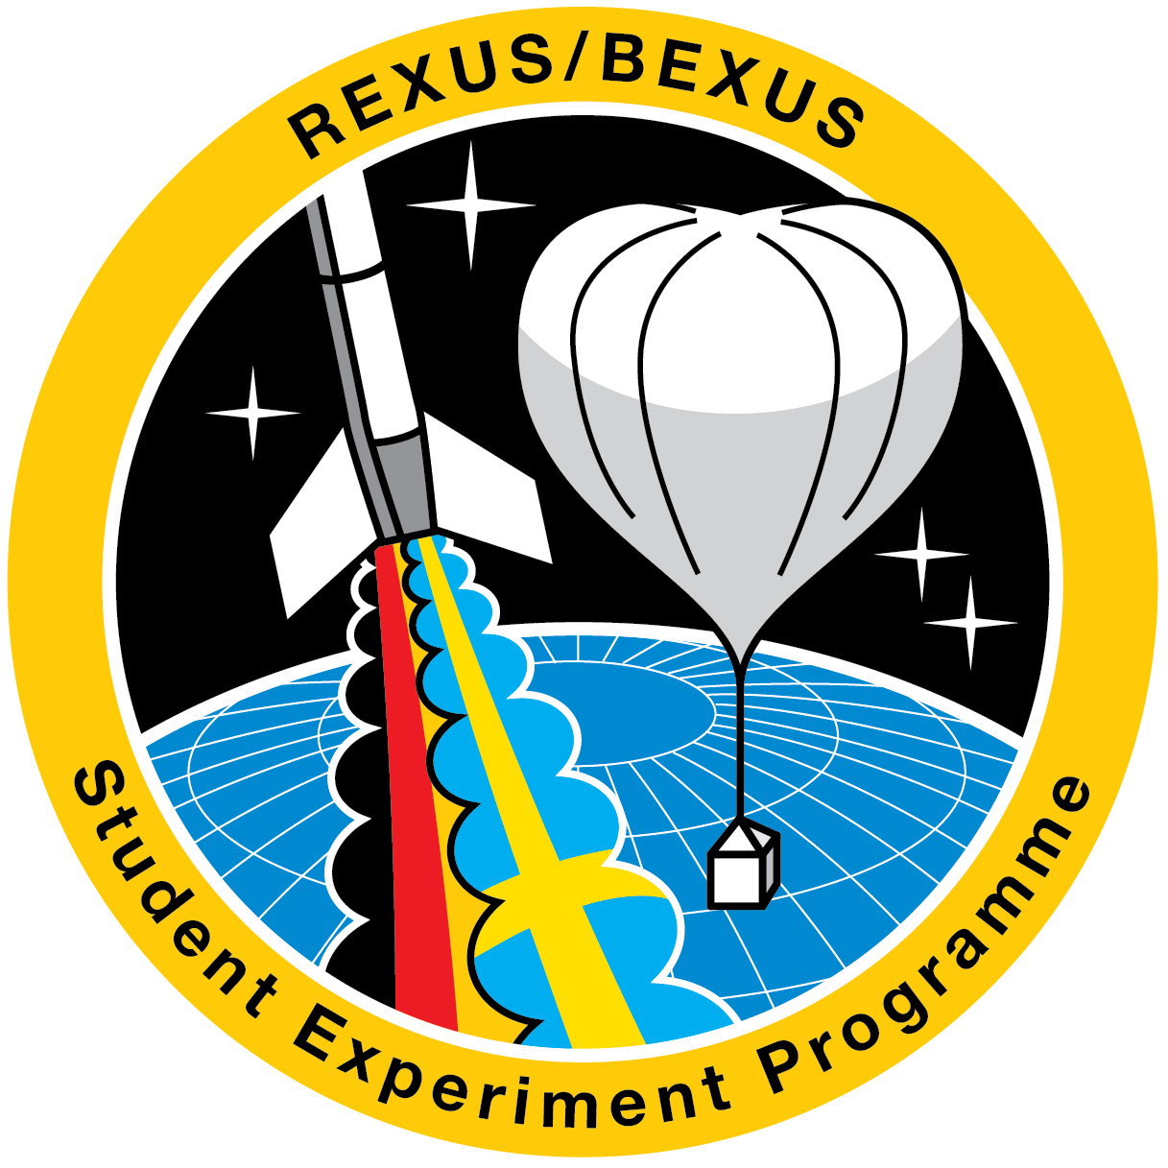

REGISTRATION FORM

REXUS / BEXUS Teams participation in the
“27th ESA Symposium on European Rocket and Balloon Programmes and Related Research"

Place: Trondheim, Norway
Date: 2026, May 31st – June 4th

Please return signed by E-mail until December 22, 2025, to mawn@zarm.uni-bremen.de and CC to rexusbexus@dlr.de

Team Name:

Family name:
First name:
University:
Home Address:
Postal code/City Country:
Telephone: E-mail:
Special dietary needs:

Date / Signature:

